PERSONALIZED LEARNING RECOMMENDATION SYSTEM
(Terminal-Based Study Recommender using Python and the Open University Learning Analytics Dataset – OULAD)
A PROJECT REPORT
SUBMITTED BY
Student Code | Student Name
BWU/BCA/24/080 | SALIM AYMAN

In partial fulfillment for the award of the degree
BACHELOR OF COMPUTER APPLICATION
IN
DEPARTMENT OF COMPUTATIONAL SCIENCE

BRAINWARE UNIVERSITY
398, Ramkrishnapur Road, Barasat, North 24 Parganas, Kolkata - 700 125

ABSTRACT
The Personalized Learning Recommendation System is a terminal-based application written in Python that helps a college student convert raw subject marks into a clear, actionable study plan. The student enters a Student ID, selects a degree course (BCA, B.Tech, BBA or MCA), chooses at least six subjects, and supplies marks, daily study hours and a preferred learning method. The program immediately produces a subject-wise performance analysis, a ranked list of weak subjects, topic-wise recommendations with direct video and notes links, a personalised seven-day study planner and a rule-based improvement scenario.
Marks are validated in the range 0–100 and mapped to five proficiency levels: Excellent, Good, Average, Weak and Very Weak. Any subject scoring below 60% is treated as weak and is ranked by urgency; for each weak subject the system selects three to five topics from an internal syllabus catalogue and builds YouTube and Google search links. Every analysis is stored in a JSON file (data/student_progress.json), so that a later attempt of the same Student ID is compared with the previous one, subject by subject.
The system is also connected to the Open University Learning Analytics Dataset (OULAD). Seven OULAD CSV files (studentInfo, assessments, studentAssessment, studentVle, vle, courses and studentRegistration) are loaded with pandas, merged into one student-level table containing assessment, learning-activity and registration features, and used to train and evaluate a scikit-learn Random Forest classifier that predicts the OULAD final_result class (Distinction, Pass, Fail or Withdrawn). The accuracy, precision, recall and F1-score are printed and the trained model is saved with joblib.
The project demonstrates input validation, rule-based educational analytics, JSON-based persistence, data merging and preprocessing with pandas, and supervised machine learning with scikit-learn, giving students a clear path towards academic improvement.

INDEX
- ABSTRACT
- LIST OF FIGURES
- LIST OF TABLES
- LIST OF SCREENSHOTS
- 1. INTRODUCTION
- 2. LITERATURE SURVEY
- 3. SYSTEM ANALYSIS AND DESIGN
- 4. IMPLEMENTATION
- 5. OUTPUT SCREENSHOTS
- 6. TESTING AND DEBUGGING
- 7. CONCLUSION AND FUTURE ENHANCEMENT
- 8. REFERENCES

LIST OF FIGURES
Figure No. | Title
Fig. 3.1 | System architecture of the Personalized Learning Recommendation System
Fig. 3.2 | Layered (theoretical) architecture of the system
Fig. 3.3 | System flow chart
Fig. 3.4 | Data Flow Diagram – Level 0 (context diagram)
Fig. 3.5 | Data Flow Diagram – Level 1

LIST OF TABLES
Table No. | Title
Table 3.1 | Technologies used
Table 3.2 | Proficiency levels and score ranges
Table 3.3 | Priority, number of recommended topics and study-plan task
Table 3.4 | Courses and subject catalogue
Table 3.5 | Layers of the theoretical architecture
Table 3.6 | Processes of the Level 1 DFD
Table 4.1 | Main functions of f1.py
Table 4.2 | OULAD CSV files and their use
Table 4.3 | Features created from the OULAD files
Table 6.1 | Test cases and results

LIST OF SCREENSHOTS
Figure No. | Title
5.1 | Student ID, Course and Subject Selection
5.2 | Marks, Study Hours and Learning Method Entry
5.3 | Subject Performance Analysis
5.4 | Personalized Recommendations with Video and Notes Links
5.5 | Personalized 7-Day Study Planner
5.6 | Academic Improvement Scenario
5.7 | Previous Performance Comparison (Second Attempt)
5.8 | OULAD Dataset Not Found – Safe Skip
5.9 | OULAD Loading, Preprocessing and Random Forest Training

1. INTRODUCTION
Higher-education programmes such as BCA, B.Tech, BBA and MCA contain many subjects, and every student has different strengths and weaknesses. Traditional academic guidance is usually uniform: the same lecture schedule, the same textbook list and the same general advice for everyone. After an internal or semester examination a student sees a list of marks, but often cannot tell which topics need attention first, how many hours to give each subject, or where to find reliable material to revise.
The Personalized Learning Recommendation System addresses this gap. It is a terminal-based Python program (file f1.py) in which the student selects a course, chooses the subjects of the semester, enters marks, daily study hours and a preferred learning method, and receives a complete study guide: an overall average, a ranked list of weak subjects, topic-wise resource links, a seven-day plan that matches the available daily hours and a rule-based improvement scenario. In addition, the program loads the Open University Learning Analytics Dataset (OULAD) and trains a Random Forest classifier on historical student data.

1.1 Objectives
- To analyse subject-wise marks and classify each subject into a clear proficiency level.
- To identify weak subjects (below 60%) and rank them by urgency so that the most critical subject is handled first.
- To recommend specific topics for each weak subject and provide direct links to video tutorials and revision notes.
- To generate a personalised seven-day study planner based on the daily study hours entered by the student.
- To adapt the study advice to the learning method preferred by the student.
- To store every attempt so that progress between two attempts can be compared subject by subject.
- To integrate the OULAD dataset and train a Random Forest model that classifies historical student results.

1.2 Scope of the Project
The system supports four courses (BCA, B.Tech, BBA and MCA) with fifteen subjects each. It is intended for self-study guidance by an individual student and runs entirely in the terminal on any computer with Python 3 and the pandas, NumPy, scikit-learn and joblib libraries. Topic lists are provided for twelve important subjects; for every other subject a generic list of eight topics is generated automatically. The OULAD part of the system analyses historical data from a different institution and is not used to predict the marks entered by the student.

1.3 Overview of the System
The program runs as a sequence of steps: collect the student data, analyse performance, generate recommendations, create the weekly planner, show the improvement scenario, save and compare progress, and finally load the OULAD CSV files and train the Random Forest model. All logic is kept in one file, f1.py, organised into clearly numbered sections (Step 1 to Step 11). Course, subject and topic data are held in two Python dictionaries, COURSE_SUBJECTS and TOPIC_MAP, so new content can be added by editing the data alone.

1.4 Advantages
- Instant feedback in the terminal without waiting for the next examination.
- Actionable output: every weak topic is paired with a video link and a notes link.
- Personalisation through course, subject choice, daily study hours and learning method.
- Progress tracking: each attempt is saved and compared with the previous one.
- Safe handling of errors: invalid input is rejected and a missing or damaged file never stops the program.
- Simple, modular code that can be extended with new courses, subjects and topics by editing data tables.

2. LITERATURE SURVEY
The project builds on ideas from Educational Data Mining (EDM), Learning Analytics (LA) and personalised learning. These fields study how data about learners, such as marks, activity and preferences, can be converted into feedback that improves learning outcomes.
The Open University Learning Analytics Dataset (OULAD) is a publicly available dataset that contains demographic data, assessment results and clicks on the virtual learning environment (VLE) of students enrolled in several Open University modules. It is widely used in research on predicting student performance and dropout. Studies based on it repeatedly show that learning-activity and assessment data collected early in a course help to identify students who are falling behind, so that timely support can be offered. This project uses OULAD in the same spirit: the assessment, VLE, registration and course files are merged into one table and used to train a classifier for the final result of a student.
Random Forest, introduced by Leo Breiman, is an ensemble method that builds many decision trees on random samples of the data and features and combines their votes. It handles a mixture of numeric and categorical features, is robust against over-fitting compared with a single tree, and works well on tabular data such as OULAD. For these reasons it was chosen as the classifier in this project, with balanced class weights to reduce the effect of unequal class sizes.
Feedback is most helpful when it is accompanied by concrete next steps. A bare percentage tells a student that something is wrong, but not what to do about it. Converting a low score into a small, ordered list of topics, a resource for each topic and a daily timetable reduces the effort of planning and makes the feedback easier to act on. Rule-based recommendation is suitable for this task because the rules (score thresholds, weak-subject limit, number of topics per score band) are transparent, can be explained to the student and need no training data.
Based on these observations, the system combines rule-based diagnosis, resource mapping, weekly scheduling and progress tracking for the individual student with a machine-learning component trained on the OULAD dataset.

3. SYSTEM ANALYSIS AND DESIGN
System analysis and design define what the system must do and how its parts fit together.

3.1 System Analysis

Existing System
In most institutions marks are shown in static spreadsheets or printed grade cards. Guidance on what to revise is informal. Students decide for themselves which topics matter, search the internet for material of uncertain quality and estimate their own study hours.

Problems in the Existing System
- No immediate link between marks and the specific topics that need revision.
- No study schedule that adapts to the student's daily availability and learning preference.
- Time spent searching for reliable material across the web.
- No easy way to compare one attempt with the previous one.
- No connection between a student's own results and patterns found in large learning-analytics datasets.

Proposed System
The proposed system accepts the student's ID, course, subjects, marks, daily study hours and preferred learning method. It calculates the average, classifies each subject, identifies weak subjects, selects topics from a syllabus catalogue, builds search links, creates a weekly plan, shows a rule-based improvement scenario and records the attempt for later comparison. It then loads the OULAD CSV files, merges them and trains a Random Forest classifier whose accuracy and classification report are displayed.

Functional Requirements
- Select one of four courses and load its subject list.
- Select at least six different subjects and enter marks between 0 and 100 for each.
- Accept daily study hours between 0.5 and 16 and one of four learning methods.
- Display the status of each subject, the overall average and the list of weak subjects.
- Show topics with video and notes links for every weak subject, with the priority level.
- Generate a seven-day planner and a weekly study target.
- Save every attempt and show the change against the previous attempt.
- Load and merge the OULAD CSV files, train and evaluate a Random Forest model and save it.

Non-Functional Requirements
- Fast response: the student analysis is produced immediately after the last input.
- Usability: numbered menus, clear messages and repeated prompts until the input is valid.
- Reliability: a missing dataset, a missing CSV file or a damaged progress file is handled without a crash.
- Maintainability: course, subject and topic data are held in simple dictionaries in the code.
- Portability: runs on any computer with Python 3 and four common libraries; no web server or database is needed.

3.2 System Design

Modules of the System
- Configuration Module – defines the project folders, creates the data and models folders and sets the file names for the progress file and the trained model.
- Catalogue Module – holds COURSE_SUBJECTS (four courses, fifteen subjects each) and TOPIC_MAP (ten topics for each of twelve subjects) and returns a generic topic list through get_topics() when a subject has no entry.
- Student Input Module – collect_student_data() together with get_integer() and get_float() collects and validates the Student ID, course, subjects, marks, study hours and learning method.
- Performance Analysis Module – analyze_performance() computes the average, assigns a status to each subject and returns the weak subjects sorted by marks.
- Recommendation Module – generate_recommendations() assigns a priority, selects three to five topics and builds YouTube and Google search links; it also prints advice for the chosen learning method.
- Weekly Study Planner Module – create_study_plan() distributes the weak subjects (or all subjects if none is weak) over seven days and prints the weekly study target.
- Improvement Scenario Module – improvement_scenario() calculates a rule-based projected average from the current average and the daily study hours.
- Progress Tracking Module – save_progress() stores each attempt in data/student_progress.json and compares it with the previous attempt.
- OULAD Machine-Learning Module – load_oulad_dataset(), preprocess_oulad_data(), train_oulad_model() and run_oulad_analysis() load, merge, clean and model the OULAD data.

System Architecture
The system is a single-process, terminal-based application. The student interacts through the keyboard and the screen. The application reads and writes the JSON progress file, builds search URLs for external video and notes sites, and reads the OULAD CSV files, from which it trains a Random Forest model that is saved as a .pkl file. Fig. 3.1 shows the components and the data stores.
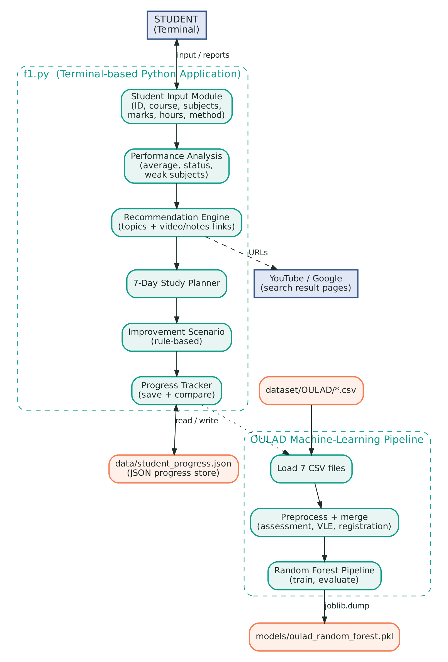
Fig. 3.1: System architecture of the Personalized Learning Recommendation System

Technologies Used
Layer | Technology
Language | Python 3 (standard library: os, json, warnings, pathlib, urllib.parse)
Numerical computing | NumPy (average of marks)
Data handling | pandas (reading CSV files, merging, group-by aggregation, cleaning)
Machine learning | scikit-learn (ColumnTransformer, Pipeline, SimpleImputer, OneHotEncoder, RandomForestClassifier, train_test_split, accuracy_score, classification_report)
Model storage | joblib (saving the trained pipeline as oulad_random_forest.pkl)
Data storage | JSON file (data/student_progress.json) and OULAD CSV files (dataset/OULAD)
Interface | Terminal / command prompt
Tools | Visual Studio Code or any Python IDE
Table 3.1: Technologies used

Proficiency Levels
Score range | Status | Weak subject?
75 and above | Excellent | No
60 to 74 | Good | No
50 to 59 | Average | Yes
40 to 49 | Weak | Yes
Below 40 | Very Weak | Yes
Table 3.2: Proficiency levels and score ranges

Recommendation Rules
Score of weak subject | Priority | Topics recommended | Study-plan task
Below 40 | HIGH | 5 topics | Learn basic concepts and solve easy questions
40 to 49 | HIGH | 4 topics | Revise important topics and practice questions
50 to 59 | MEDIUM | 3 topics | Revise important topics and practice questions
60 and above (no weak subject) | – | – | Revision, advanced topics and mock tests
Table 3.3: Priority, number of recommended topics and study-plan task
Weak subjects are sorted in ascending order of marks, so the subject with the lowest score is always shown first. The topics are taken from the beginning of the topic list of the subject, which is arranged from basic to advanced. When a subject has no entry in TOPIC_MAP, a generic list of eight topics is used (Introduction, Basic Concepts, Fundamentals, Important Terminologies, Core Principles, Applications, Practical Examples and Advanced Concepts of the subject). The advice printed under HOW TO STUDY depends on the learning method: video lectures with short notes, textbook reading and revision, practical problems, or a combination of all three.

Course Catalogue
Course | Subjects | Examples
BCA | 15 | Python Programming, Data Structures, Database Management System, Operating System, Cyber Security
B.Tech | 15 | Engineering Mathematics, Engineering Physics, Digital Electronics, Design and Analysis of Algorithms
BBA | 15 | Principles of Management, Financial Accounting, Marketing Management, Digital Marketing
MCA | 15 | Advanced Java, Cloud Computing, Data Science, Mobile Application Development
Table 3.4: Courses and subject catalogue

3.3 Theoretical Architecture
The design is based on three well-known ideas from software engineering: layered architecture, modular programming and rule-based processing combined with supervised machine learning.
- Layered architecture: the program is divided into layers, each with one responsibility and each talking only to the layer next to it. This separation of concerns keeps the code easy to understand, test and change; for example, the topic catalogue can be extended without touching the input or analysis code.
- Modular programming: every task is implemented as a separate function (input, analysis, recommendation, planning, scenario, tracking, loading, preprocessing and training), and main() calls them in order.
- Rule-based processing: the analysis of the student's marks uses explicit rules (score thresholds, weak-subject limit of 60%, topic counts per score band). Rules are transparent, can be explained to the student and need no training data.
- Supervised machine learning: the OULAD part uses labelled historical data (final_result) to train a Random Forest classifier inside a scikit-learn pipeline, so that preprocessing and classification are applied in the same way during training and prediction.
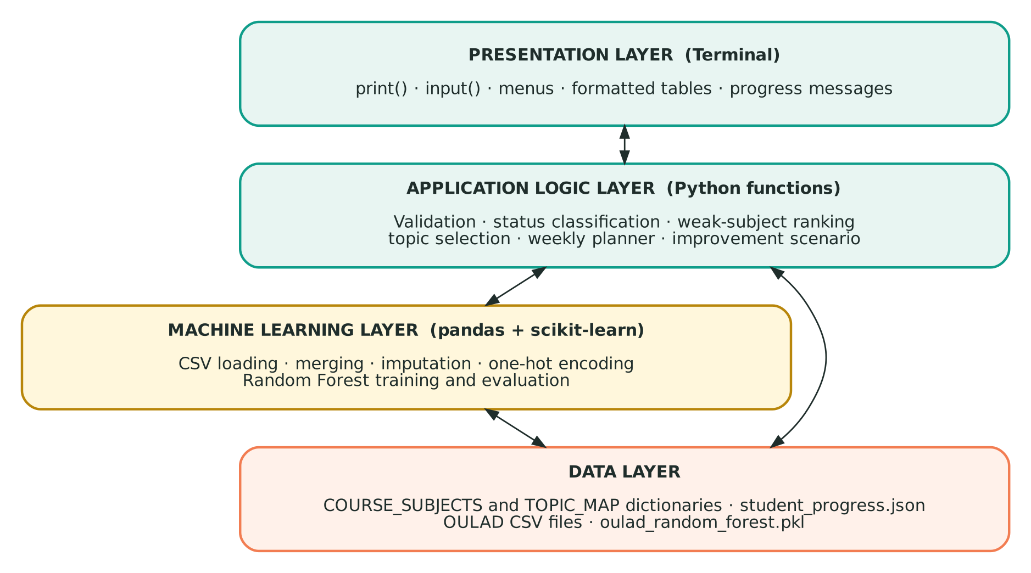
Fig. 3.2: Layered (theoretical) architecture of the system
Layer | Responsibility
Presentation layer | Shows menus, prompts, tables and messages in the terminal and collects the keyboard input.
Application logic layer | Validates input, classifies marks, ranks weak subjects, selects topics, builds the weekly plan and calculates the improvement scenario.
Machine learning layer | Loads and merges the OULAD files, handles missing values, encodes categorical features, trains and evaluates the Random Forest and saves the model.
Data layer | Course and topic dictionaries in the code; progress in data/student_progress.json; OULAD CSV files; the saved model file.
Table 3.5: Layers of the theoretical architecture

3.4 System Flow
The flow chart in Fig. 3.3 shows the sequence of actions from start to end. At each input step the value is checked and, if it is invalid, a message is shown and the student is asked again. After valid data is entered, the system classifies the marks, generates the recommendations (or an encouraging message when no subject is weak), creates the weekly planner, shows the improvement scenario and saves the attempt. Finally it checks that the OULAD folder and the six required CSV files exist; if they do, the data is merged and the Random Forest model is trained, otherwise the OULAD analysis is skipped.
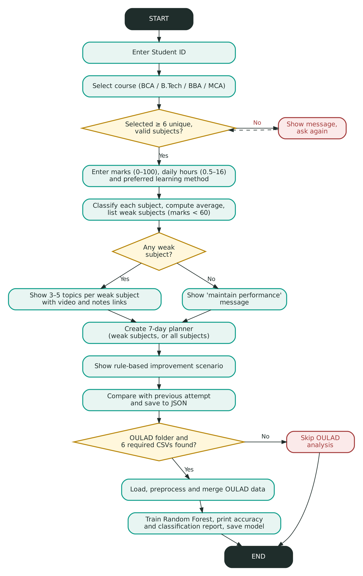
Fig. 3.3: System flow chart

3.5 Data Flow Diagrams
A Data Flow Diagram (DFD) shows how data moves between external entities, processes and data stores. The notation used here is: rectangle = external entity, circle = process, open box = data store, arrow = data flow.

Level 0 DFD (Context Diagram)
At level 0 the whole application is a single process. The student supplies the details and marks and receives the analysis, recommendations, weekly plan, scenario and progress comparison. The process reads and writes the progress store, reads the OULAD dataset, saves the trained model and gives the student search links to external sites (YouTube and Google).
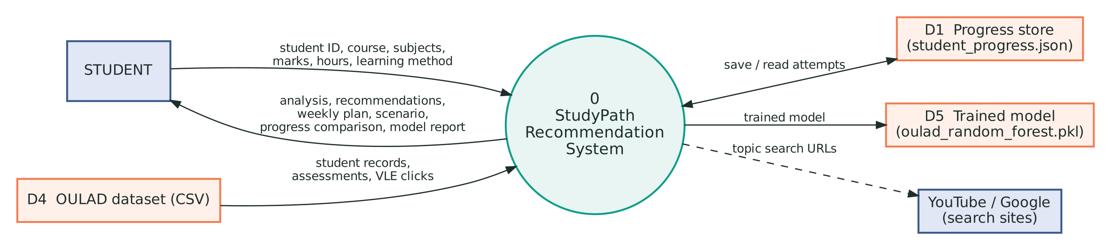
Fig. 3.4: DFD Level 0 (context diagram)

Level 1 DFD
Level 1 divides the system into seven processes: 1.0 Collect and validate input, 2.0 Analyse performance, 3.0 Recommend topics, 4.0 Weekly planner, 5.0 Improvement scenario, 6.0 Save and compare, and 7.0 OULAD model training. The course catalogue (D3), topic catalogue (D2), progress store (D1), OULAD CSV files (D4) and model file (D5) are the data stores.
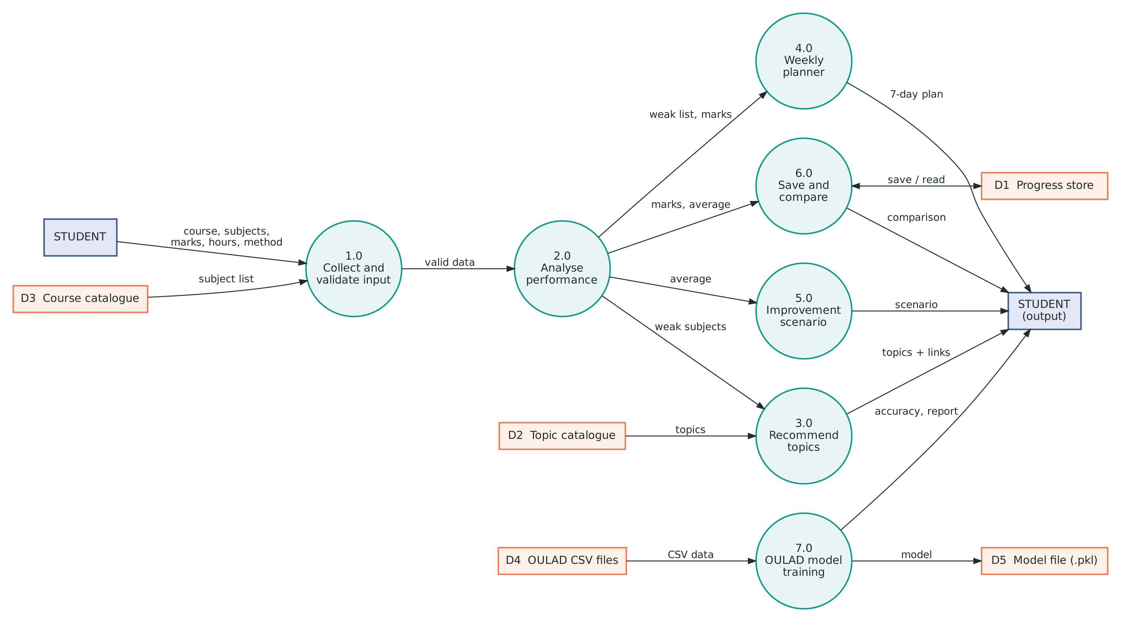
Fig. 3.5: DFD Level 1
Process | Input | Output
1.0 Collect and validate input | Student ID, course, subjects, marks, hours, method; course subjects (D3) | Valid student data, or a message and a new prompt
2.0 Analyse performance | Valid marks | Status of each subject, average, weak subjects (sorted)
3.0 Recommend topics | Weak subjects; topics (D2); learning method | Priority, topic list with video and notes links, study advice
4.0 Weekly planner | Weak list, marks, daily study hours | 7-day plan and weekly study target
5.0 Improvement scenario | Average, study hours | Projected average and difference
6.0 Save and compare | Course, marks, average; earlier attempts (D1) | Saved attempt; change from the previous attempt
7.0 OULAD model training | OULAD CSV files (D4) | Accuracy, classification report and saved model (D5)
Table 3.6: Processes of the Level 1 DFD

4. IMPLEMENTATION
The project is organised as a small Python project. The main program is f1.py. The folder dataset/OULAD holds the OULAD CSV files, data/ holds student_progress.json (created automatically) and models/ holds oulad_random_forest.pkl (created automatically after training). The code in f1.py is divided into eleven numbered steps; Table 4.1 lists the main functions.
Function | Step | Purpose
get_topics(subject) | 3 | Returns the topic list of a subject, or eight generic topics if the subject is not in TOPIC_MAP
get_integer(), get_float() | 4 | Read a number inside a given range and repeat the prompt until the input is valid
collect_student_data() | 4 | Collects Student ID, course, at least six subjects, marks, daily hours and learning method
analyze_performance(marks) | 5 | Prints the status of each subject, computes the average and returns the weak subjects
generate_recommendations() | 6 | Prints priority, topics, video and notes links and study advice for each weak subject
create_study_plan() | 7 | Prints the 7-day planner and the weekly study target
improvement_scenario() | 8 | Prints the current average and a rule-based projected average
save_progress() | 9 | Saves the attempt in JSON and compares it with the previous attempt
load_oulad_dataset() | 10.1 | Checks the dataset folder and reads the CSV files with pandas
preprocess_oulad_data() | 10.2 | Merges the CSV files and builds student-level features
train_oulad_model() | 10.3 | Trains, evaluates and saves the Random Forest pipeline
run_oulad_analysis(), main() | 10.4, 11 | Run the OULAD pipeline and the complete program in order
Table 4.1: Main functions of f1.py

4.1 Configuration and Libraries (Step 1)
The program imports os, json, warnings, pathlib and urllib.parse from the standard library, NumPy and pandas for data handling, joblib for saving the model and several scikit-learn classes for the machine-learning pipeline. BASE_DIR is the folder of f1.py (found with Path(__file__)), DATASET_DIR points to dataset/OULAD, and the folders data and models are created with mkdir(exist_ok=True) so that the program never fails because a folder is missing. PROGRESS_FILE and MODEL_FILE give the locations of the progress file and the trained model. Warnings are suppressed to keep the terminal output clean.

4.2 Course and Topic Catalogue (Steps 2 and 3)
COURSE_SUBJECTS is a dictionary that maps each course (BCA, B.Tech, BBA, MCA) to a list of fifteen subjects. TOPIC_MAP maps twelve important subjects (Python Programming, Java Programming, C Programming, C++ Programming, Data Structures, Database Management System, Operating System, Computer Networks, Machine Learning, Artificial Intelligence, Software Engineering and Web Development) to ten topics each, arranged from basic to advanced. The function get_topics() returns the stored list or, for any other subject, builds a generic list of eight topics from the subject name, so no subject ever produces an empty recommendation.

4.3 Student Input (Step 4)
get_integer() and get_float() display a prompt inside a while True loop, convert the text to a number with int() or float(), accept it only if it lies between the given minimum and maximum and otherwise print an error message. A ValueError from non-numeric text is caught and reported. collect_student_data() uses these helpers and performs the following checks:
- Student ID: an empty ID is replaced by DEFAULT_STUDENT.
- Course: chosen by its number in the displayed list.
- Subjects: the student enters numbers separated by commas; duplicates, fewer than six subjects, numbers outside the list and non-numeric text are rejected and the prompt is repeated.
- Marks: a mark between 0 and 100 is read for each selected subject.
- Daily study hours: between 0.5 and 16.
- Learning method: Video Tutorials, Books and Notes, Practical Exercises or Mixed Learning.
The function returns a dictionary with the keys student_id, course, marks, study_hours and learning_method.

4.4 Performance Analysis (Step 5)
analyze_performance() calculates the average with numpy.mean() and assigns a status to every subject using the thresholds of Table 3.2. Subjects below 60 are added to the weak-subject list, which is then sorted by marks so that the lowest score comes first. The status table, the overall average and the numbered list of subjects requiring improvement are printed.
if score >= 75: status = "Excellent"
elif score >= 60: status = "Good"
elif score >= 50: status = "Average"
elif score >= 40: status = "Weak"
else: status = "Very Weak"
if score < 60:
weak_subjects.append(subject)
weak_subjects.sort(key=lambda x: marks[x])

4.5 Personalized Recommendations (Step 6)
For each weak subject generate_recommendations() sets the priority and the number of topics: below 40 marks – HIGH priority, five topics; 40 to 49 – HIGH, four topics; 50 to 59 – MEDIUM, three topics. For every recommended topic two links are built with urllib.parse.quote_plus(): a YouTube search for "<subject> <topic> tutorial" and a Google search for "<subject> <topic> notes". No resource has to be stored or maintained in the project. The section HOW TO STUDY then prints advice that matches the learning method chosen by the student. If no subject is weak, the message “Maintain your performance with regular revision.” is shown.

4.6 Weekly Study Planner (Step 7)
create_study_plan() uses the weak subjects as a pool, or all selected subjects when there is no weak subject. The seven days from Monday to Sunday receive one subject each from the pool in rotation (index modulo pool size), together with the daily study hours entered by the student and a task selected by the score of the subject (Table 3.3). The weekly study target is the daily hours multiplied by seven.

4.7 Improvement Scenario (Step 8)
improvement_scenario() chooses a base improvement from the current average: 12 points if the average is below 40, 8 if below 60, 5 if below 75 and 2 otherwise. The base is multiplied by min(study_hours / 3, 1.5), so more study hours increase the scenario but never by more than one and a half times. The projected average is the current average plus this improvement, limited to 100. The output states clearly that this is a rule-based planning scenario and not a validated machine-learning prediction or a guarantee.
improvement *= min(study_hours / 3, 1.5)
projected_average = min(100, average + improvement)

4.8 Progress Tracking (Step 9)
save_progress() reads data/student_progress.json (an empty dictionary is used if the file is missing or damaged, because json.JSONDecodeError and OSError are caught), finds the list of earlier attempts of the Student ID and, if one exists, prints the previous and current averages, whether the performance improved, decreased or remained the same, and the change in every subject that appears in both attempts. The new attempt (course, marks and rounded average) is appended and the file is written back with indent=4.

4.9 OULAD Dataset Integration (Step 10)
The OULAD files are read from dataset/OULAD. load_oulad_dataset() checks that the folder and the six required files exist and reads them with pandas.read_csv(); the optional studentRegistration.csv is loaded if it is present. If the folder or a required file is missing, a message is printed and the OULAD analysis is skipped without stopping the program.
CSV file | Content | Use in the project
studentInfo.csv | Student profile (gender, region, education, age band, previous attempts, credits, disability) and final_result | Base table and target variable
assessments.csv | Assessment type, due date and weight | Merged with studentAssessment to find late submissions
studentAssessment.csv | Submission date and score of every student assessment | Average score, assessment count, late submissions
studentVle.csv | Daily clicks of every student on VLE resources | Total clicks, active days, unique resources
vle.csv | Information about each VLE resource | Supplies module and presentation codes for activity records
courses.csv | Module, presentation and presentation length | Adds module_presentation_length
studentRegistration.csv (optional) | Registration and un-registration dates | Adds date_registration and date_unregistration
Table 4.2: OULAD CSV files and their use

Preprocessing and Merging
preprocess_oulad_data() builds one row per student and module presentation in the following way:
- Assessment features: studentAssessment is merged with assessments on id_assessment; score, date_submitted and date are converted to numbers; a submission is marked late when date_submitted is greater than the due date; the data is grouped by id_student, code_module and code_presentation.
- VLE features: studentVle is merged with vle on id_site and grouped in the same way to obtain total clicks, number of active days and number of unique resources.
- Course and profile data: studentInfo is merged with courses on code_module and code_presentation.
- Feature merge: the assessment and VLE features, and the registration dates when available, are merged into the student table with left joins.
- Cleaning: missing values of the six numeric activity features are replaced by 0 (a student with no record has no activity), and rows without final_result are removed.
Feature | Meaning | Source
average_assessment_score | Mean score of the student's assessments | studentAssessment
assessment_count | Number of assessments with a score | studentAssessment
late_submission_count | Number of assessments submitted after the due date | studentAssessment + assessments
total_clicks | Sum of all VLE clicks | studentVle
active_days | Number of different days with VLE activity | studentVle
unique_resources | Number of different VLE resources used | studentVle
module_presentation_length | Length of the module presentation in days | courses
date_registration, date_unregistration | Registration and un-registration day | studentRegistration
Table 4.3: Features created from the OULAD files

4.10 Random Forest Model Training (Step 10.3)
train_oulad_model() uses final_result (Distinction, Pass, Fail or Withdrawn) as the target. The identifiers id_student and final_result are removed from the inputs, and the remaining columns are divided automatically into numeric and categorical features. The numeric columns pass through a SimpleImputer with the median strategy; the categorical columns pass through a SimpleImputer with the most-frequent strategy followed by OneHotEncoder(handle_unknown="ignore"). A ColumnTransformer combines both, and a Pipeline joins it with RandomForestClassifier(n_estimators=150, random_state=42, class_weight="balanced", n_jobs=-1).
model = Pipeline([
("preprocessor", preprocessor),
("classifier", random_forest)
])
X_train, X_test, y_train, y_test = train_test_split(
X, y, test_size=0.20, random_state=42, stratify=stratify_target)
model.fit(X_train, y_train)
joblib.dump(model, MODEL_FILE)

The data is split 80% for training and 20% for testing; stratification is used only when every class has at least two records, and the training is skipped if fewer than ten records are available. After fitting, the program prints the accuracy and the classification report (precision, recall, F1-score and support for each class) and saves the complete pipeline with joblib. The program states that the model classifies historical OULAD patterns and is not a validated forecast of the student's future subject marks.

4.11 Main Program (Step 11)
main() calls the functions in the following order: collect_student_data(), analyze_performance(), generate_recommendations(), create_study_plan(), improvement_scenario(), save_progress() and run_oulad_analysis(), and finally prints that the personalised learning analysis is completed. The program starts through the usual if __name__ == "__main__": main() entry point.

5. OUTPUT SCREENSHOTS
The screenshots below were captured from the running program (BCA course, Student ID BWU/BCA/24/080, six subjects, 3 hours of daily study and the Mixed Learning method). Figures 5.7 and 5.9 were captured in a second run with improved marks. As the full OULAD files were not available on the computer used for the screenshots, Figs. 5.8 and 5.9 show the program without the dataset and with a small sample dataset that follows the OULAD file structure; the accuracy in Fig. 5.9 therefore belongs to that sample, and a run on the complete OULAD dataset will give different values.
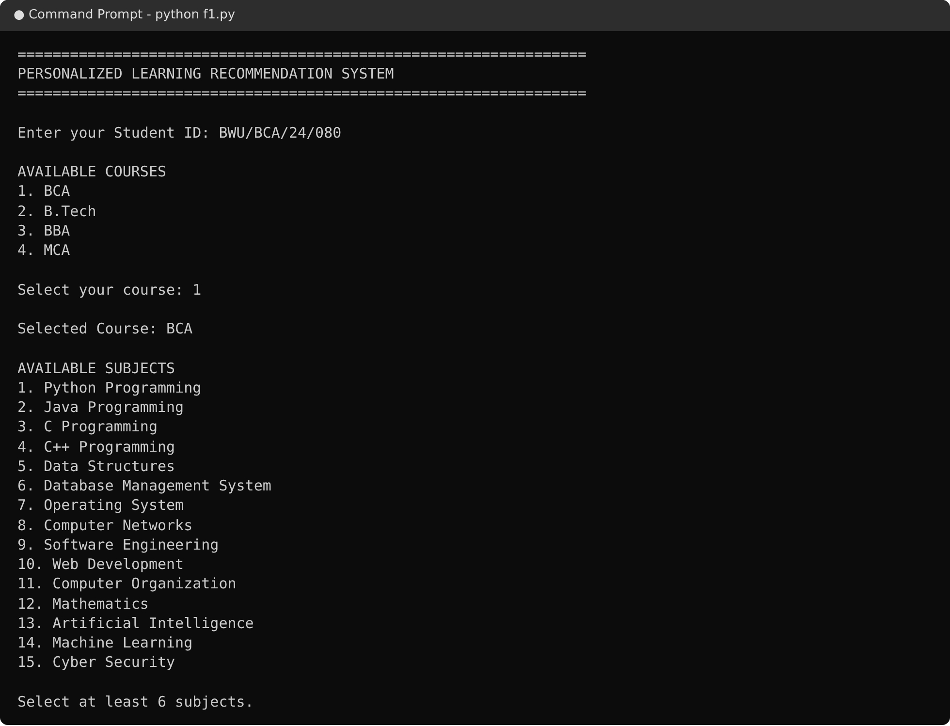
5.1 :- Student ID, Course and Subject Selection
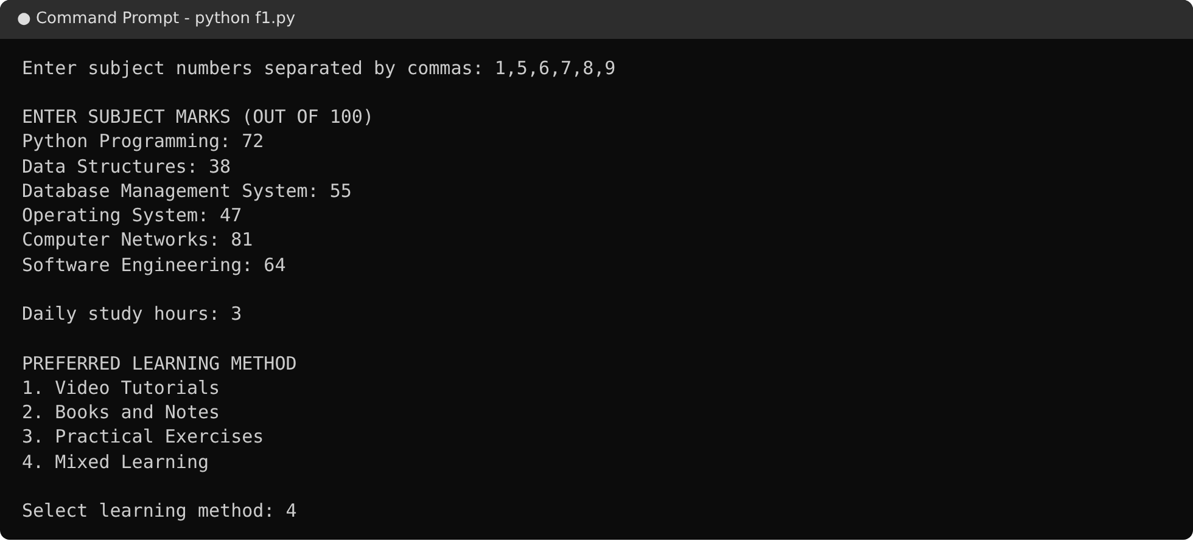
5.2 :- Marks, Study Hours and Learning Method Entry
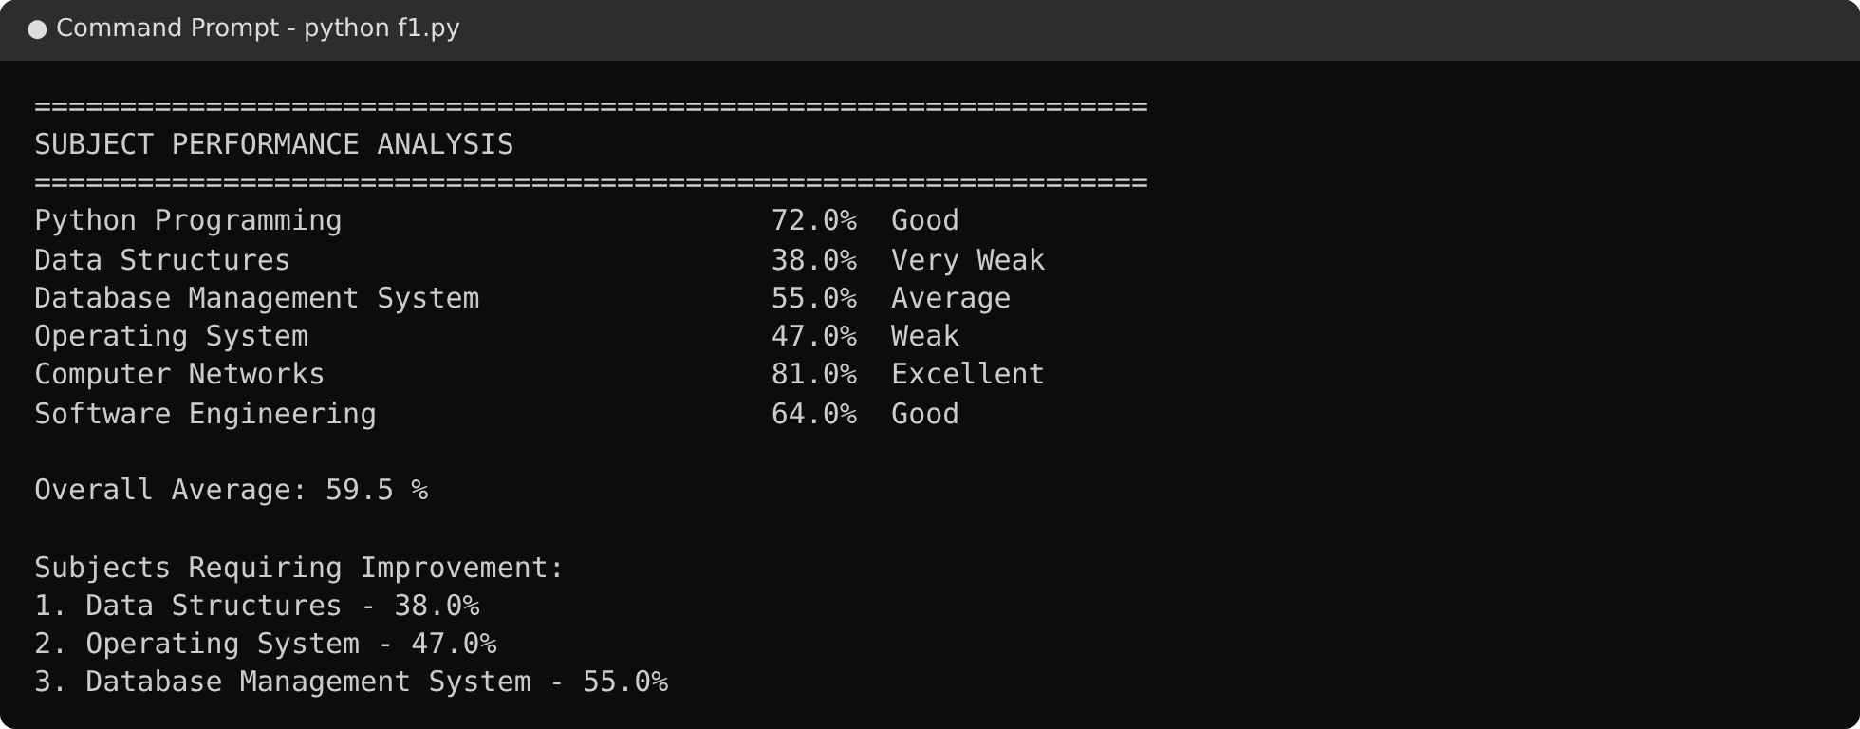
5.3 :- Subject Performance Analysis
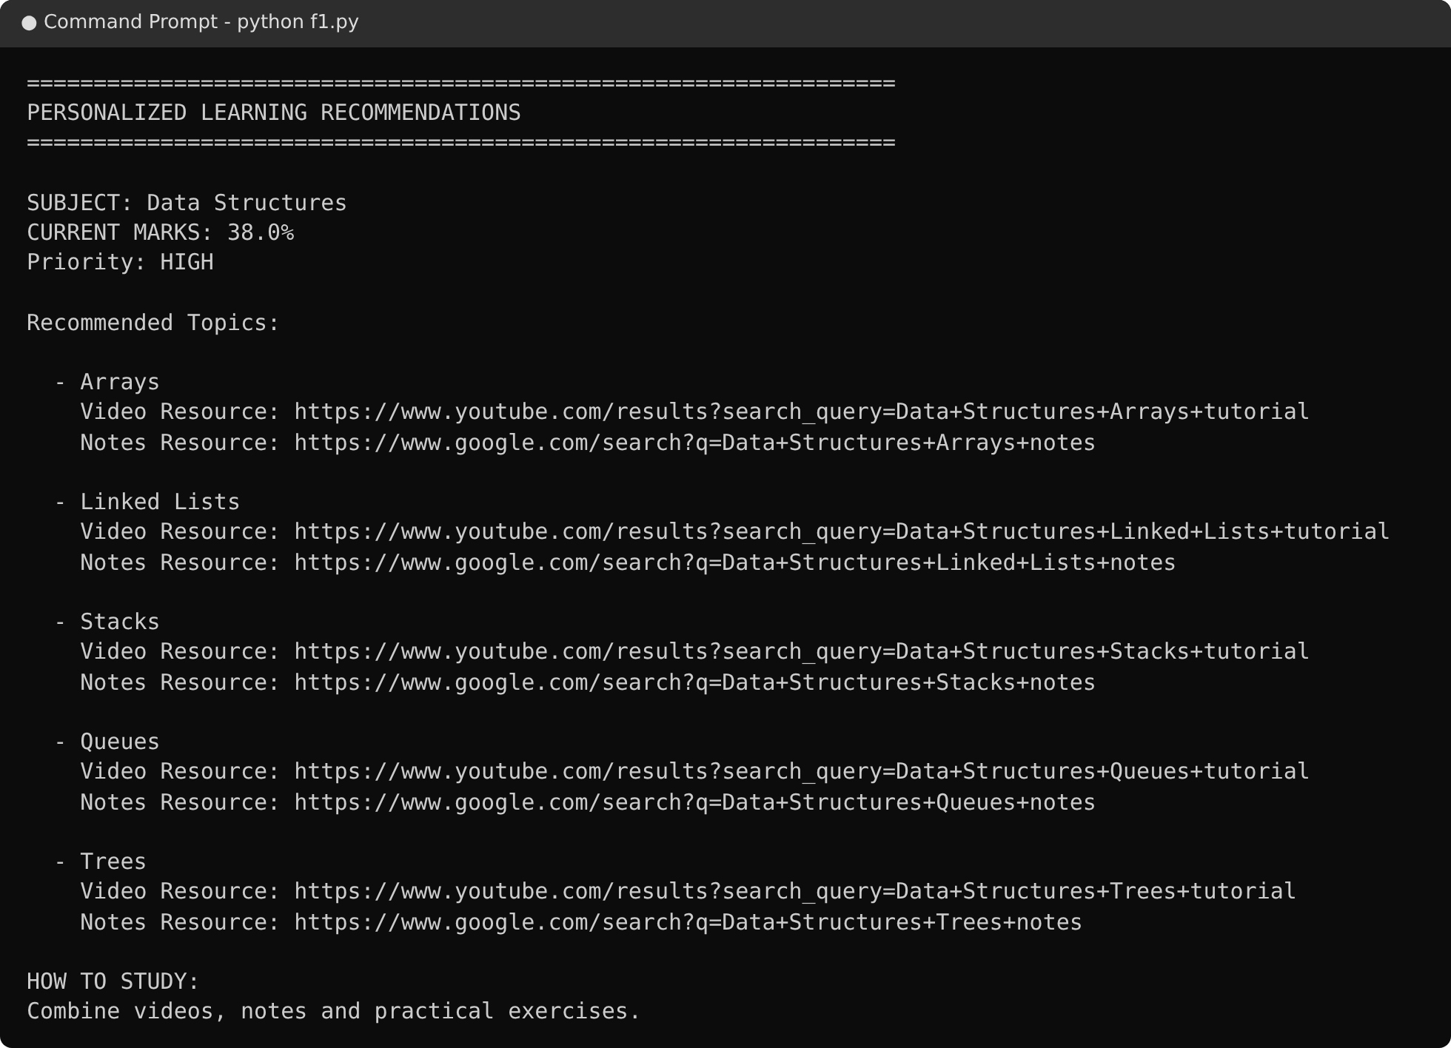
5.4 :- Personalized Recommendations with Video and Notes Links
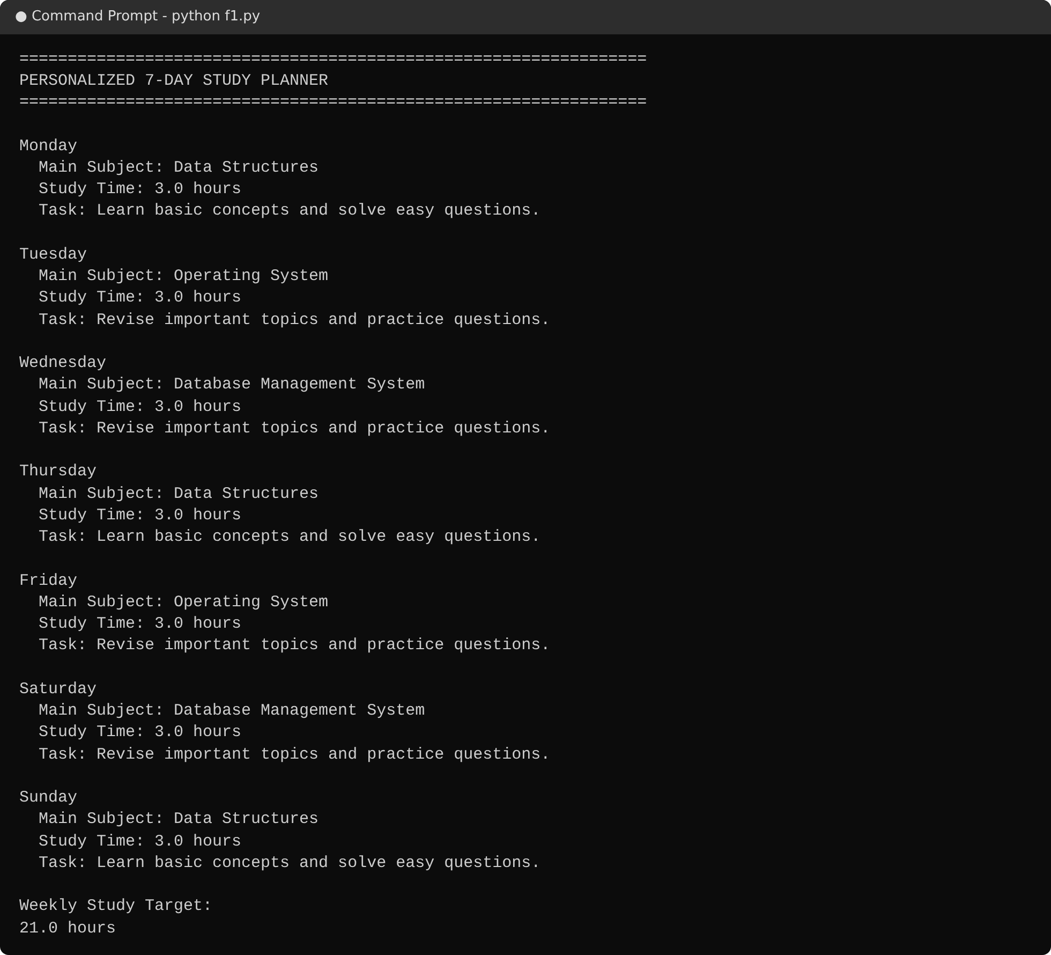
5.5 :- Personalized 7-Day Study Planner
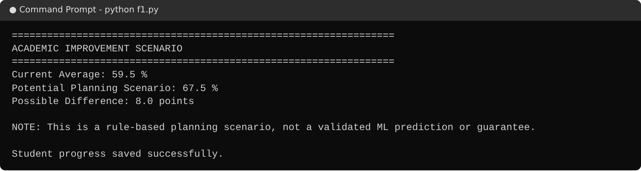
5.6 :- Academic Improvement Scenario
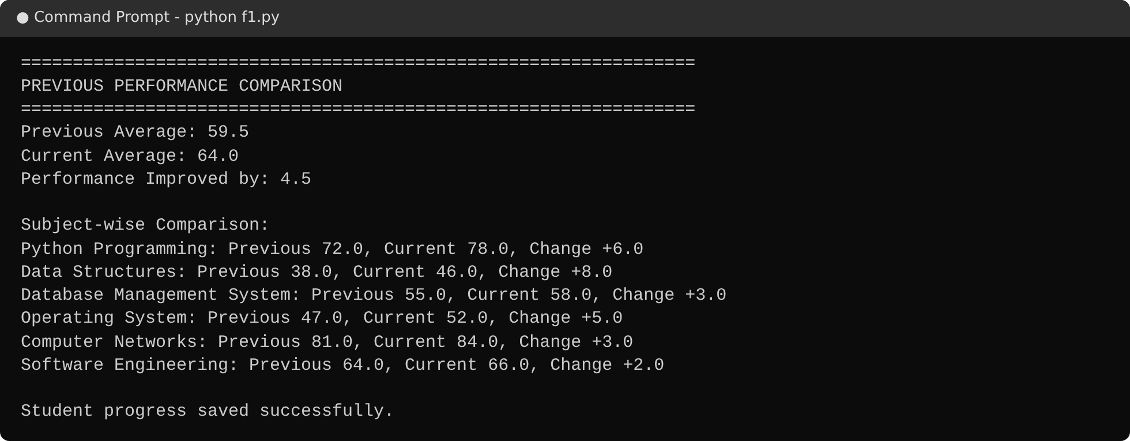
5.7 :- Previous Performance Comparison (Second Attempt)
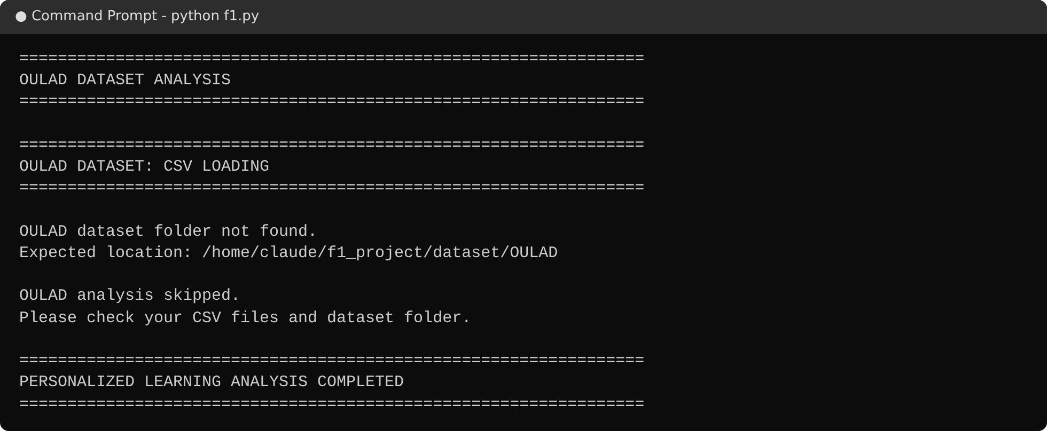
5.8 :- OULAD Dataset Not Found – Safe Skip
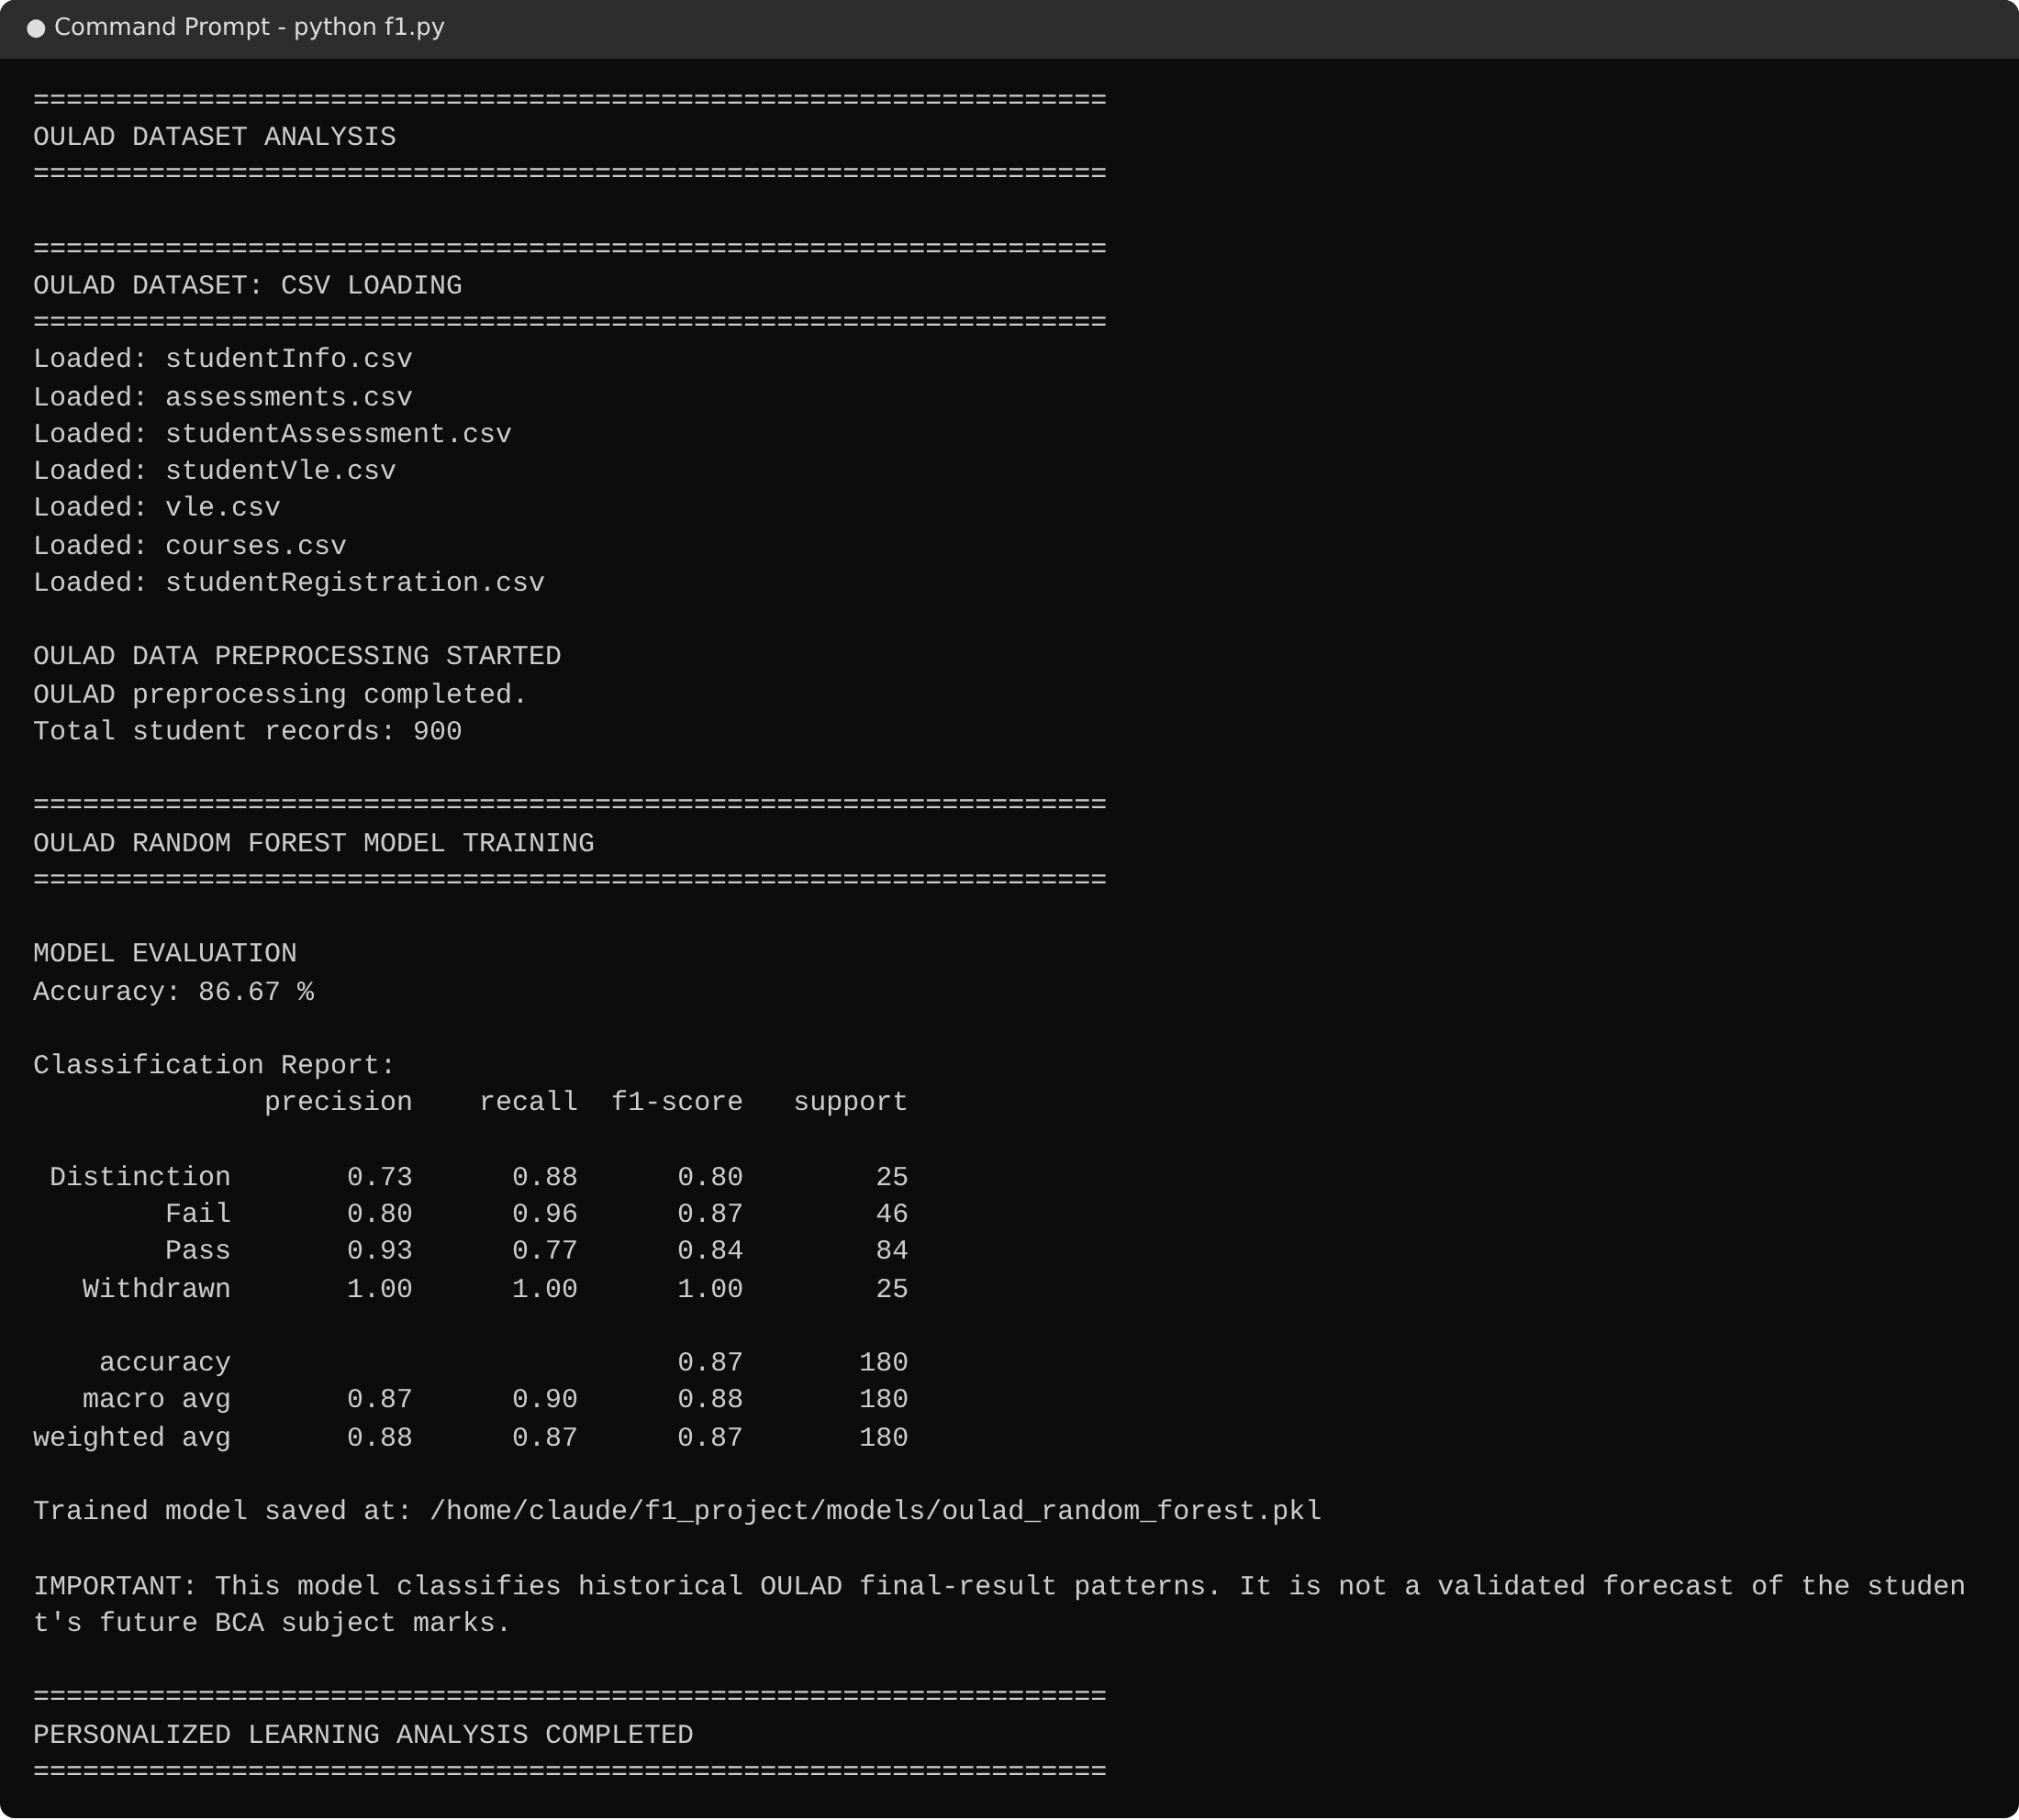
5.9 :- OULAD Loading, Preprocessing and Random Forest Training

6. TESTING AND DEBUGGING

Introduction
Testing checks that the system meets its functional requirements, and debugging finds and removes the faults that testing reveals. For this project, testing concentrated on input validation, the correctness of the scoring rules, the recommendation and planning logic, progress tracking and the handling of the OULAD files.

Types of Testing
- Unit-level testing: each function was called separately with prepared inputs. The status thresholds were checked at their boundary values (39, 40, 49, 50, 59, 60, 74 and 75), and the number of topics was checked for each score band.
- Integration testing: the input, analysis, recommendation, planner and progress functions were run together in the complete program, including two attempts of the same Student ID.
- System (functional) testing: the complete program was run from the Student ID prompt to the end of the OULAD analysis, with and without the dataset folder, and with a damaged progress file.
The tests were executed with a Python script that calls the functions of f1.py with scripted keyboard input and records the printed output. The observed results are given in Table 6.1. Test cases 15 to 18 that use OULAD files were executed on a small sample dataset with the OULAD file structure.

Test Cases
Test Id | Description | Input | Expected Result | Actual Output | Status
TC-1 | Course catalogue | COURSE_SUBJECTS | 4 courses with 15 subjects each | BCA 15, B.Tech 15, BBA 15, MCA 15 | Pass
TC-2 | Integer input validation | Range 1–4; inputs abc, 9, 0, 2 | Invalid values rejected; 2 accepted | Messages shown for abc, 9 and 0; 2 returned | Pass
TC-3 | Subject selection rules | 1,2,3 / 1,1,2,3,4,5 / 1,2,3,4,5,99 / a,b / 1,2,3,4,5,6 | Fewer than 6, duplicates, invalid number and text rejected; 6 accepted | “Please select at least 6 subjects”, “Duplicate subjects are not allowed”, “Invalid subject number”, “Enter valid subject numbers”; six subjects accepted | Pass
TC-4 | Marks validation | 101, -5, abc, 85.5 | Out-of-range and text rejected; 85.5 accepted | Range message for 101 and -5; number message for abc; 85.5 returned | Pass
TC-5 | Status boundaries | 39, 40, 49, 50, 59, 60, 74, 75 | Very Weak, Weak, Weak, Average, Average, Good, Good, Excellent | Exactly as expected | Pass
TC-6 | Priority and topic count | Five weak subjects with 39, 40, 49, 50, 59 | 5, 4, 4, 3, 3 topics; HIGH, HIGH, HIGH, MEDIUM, MEDIUM | 5, 4, 4, 3, 3 topics; HIGH, HIGH, HIGH, MEDIUM, MEDIUM | Pass
TC-7 | Resource links | First topic of Python Programming | YouTube and Google search links with subject and topic | youtube.com/results?search_query=Python+Programming+Python+Basics+tutorial and google.com/search?q=…+notes | Pass
TC-8 | Learning-method advice | Four learning methods | A different advice line for each method | Four different advice lines shown | Pass
TC-9 | No weak subject | All marks 60 or above; 2.5 h/day | Encouraging message; plan from all subjects | “Maintain your performance with regular revision.”; plan uses all subjects; target 17.5 hours | Pass
TC-10 | 7-day plan | 3 weak subjects (38, 47, 55); 3 h/day | Subjects rotate over seven days; target 21 hours | DS, OS, DBMS, DS, OS, DBMS, DS; 21 hours | Pass
TC-11 | Improvement scenario | Averages 35, 59.5, 70, 80, 98 at 3 h/day | 47.0, 67.5, 75.0, 82.0 and 100 (capped) | 47.0, 67.5, 75.0, 82.0, 100 | Pass
TC-12 | Progress comparison | Four attempts of one ID: 55, 65, 55, 55 | Improved by 10; decreased by 10; remained the same; 4 records | Messages shown as expected; 4 records stored | Pass
TC-13 | Damaged progress file | Progress file contains invalid JSON | No crash; new record saved | Saved successfully; file rebuilt | Pass
TC-14 | Subject without topic list | Mathematics | Generic list of 8 topics | 8 topics, starting with “Introduction to Mathematics” | Pass
TC-15 | Dataset folder missing | Folder does not exist | Message and OULAD analysis skipped | “OULAD dataset folder not found.” and “OULAD analysis skipped.” | Pass
TC-16 | Required CSV missing | vle.csv removed | Message and OULAD analysis skipped | “Missing CSV file: vle.csv” and analysis skipped | Pass
TC-17 | Full OULAD pipeline | Sample dataset with OULAD structure | Files loaded, records merged, accuracy printed, model saved | 7 files loaded; 900 records; accuracy printed; model file created | Pass
TC-18 | Optional registration file absent | studentRegistration.csv removed | Pipeline still runs | 900 records; accuracy printed | Pass
Table 6.1: Test cases and results

Debugging and Robustness Measures
- Input loops: every numeric prompt repeats until a valid value is entered, and ValueError from non-numeric text is caught.
- A missing or damaged progress file is handled with try/except (json.JSONDecodeError, OSError), so the program never stops because of the data file.
- The data and models folders are created automatically with mkdir(exist_ok=True).
- The OULAD analysis checks the dataset folder and every required file before reading, and prints a clear message instead of failing.
- Missing numeric features are replaced by 0 after merging, and the scikit-learn pipeline imputes remaining gaps (median for numbers, most frequent value for categories).
- OneHotEncoder uses handle_unknown="ignore", so unseen categories in the test data do not cause an error.
- Stratified splitting is applied only if every class has at least two records, and training is skipped if fewer than ten records exist.
- When no subject is below 60%, the recommendation section shows an encouraging message and the planner uses all chosen subjects, so no empty-list error occurs.

Overall Conclusion
All eighteen test cases produced the expected result. The program correctly validates input, classifies marks, produces recommendations and planners, saves and compares progress between attempts, and handles missing or damaged files safely. The OULAD pipeline loads, merges and models the data and saves the trained model.

7. CONCLUSION AND FUTURE ENHANCEMENT

Conclusion
The Personalized Learning Recommendation System achieves the aim of turning raw marks into a clear and personal study path. In a few steps the student receives an honest picture of performance, a ranked list of subjects that need attention, topic-level resources, a weekly timetable matched to the available hours, a planning scenario and a comparison with the previous attempt. The integration of the OULAD dataset adds a data-driven component: the activity, assessment and registration files are merged and a Random Forest classifier is trained and evaluated on the final results of historical students.
The code is modular and data-driven: adding a new course, subject or topic list only requires editing the dictionaries, which makes the system easy to maintain and extend.

Limitations
- The history is linked only to the Student ID typed by the user; there is no login or password.
- A single JSON file is suitable for a prototype but not for many simultaneous users, and a damaged file is replaced by a new one, so older history is lost.
- The analysis rules for the student's marks are fixed thresholds; they do not learn from data.
- The Random Forest model is trained on OULAD, which does not contain subject-wise marks of BCA, B.Tech, BBA or MCA courses. It is evaluated but not used to predict the marks of the student, and the improvement scenario is a rule-based estimate, not a prediction.
- The recommendation links are search pages, so the quality of the results depends on the search engines.
- The interface is text-based and does not draw charts.

Future Enhancement
- Use of the trained model: map a student's marks, study hours and activity to OULAD-like features and use the saved model to estimate the risk of failure or withdrawal.
- Model improvement: compare Random Forest with other models, tune the hyper-parameters, show feature importance and use cross-validation.
- Graphical interface: a web or desktop interface with charts for subject performance and progress over time.
- Database migration: replace the JSON file with SQLite, PostgreSQL or MySQL for multi-user use.
- Authentication and portals: secure student and faculty login, with a teacher dashboard for class-level analytics.
- Diagnostic micro-quizzes: topic-level quizzes after revision to measure improvement directly.
- PDF export and reminders: download the study plan as a PDF and send daily reminders by e-mail or SMS.
- Richer resources: curated, verified resource links and a tool to edit the topic catalogue.

8. REFERENCES
- Python – Official Documentation
https://docs.python.org/3/
(Core language syntax, standard libraries, json, pathlib and file handling)
- pandas – Documentation
https://pandas.pydata.org/docs/
(Reading CSV files, merging, group-by aggregation and data cleaning)
- NumPy – Documentation
https://numpy.org/doc/
(Numerical computation)
- scikit-learn – Machine Learning in Python
https://scikit-learn.org/stable/
(Pipeline, ColumnTransformer, SimpleImputer, OneHotEncoder, RandomForestClassifier and evaluation metrics)
- joblib – Documentation
https://joblib.readthedocs.io/
(Saving and loading the trained model)
- Open University Learning Analytics Dataset (OULAD)
https://analyse.kmi.open.ac.uk/open_dataset
(Student information, assessment, VLE activity and registration data)
- Kuzilek, J., Hlosta, M., Zdrahal, Z. – Open University Learning Analytics dataset, Scientific Data, 4, 170171 (2017)
https://www.nature.com/articles/sdata2017171
(Description of the dataset)
- Breiman, L. – Random Forests, Machine Learning, 45(1), 5–32 (2001)
https://doi.org/10.1023/A:1010933404324
(Random Forest algorithm)
- Class notes and study materials provided by Brainware University
(Academic background and course content)

